**1- DEPLOYING WORDPRESS WEB APPLICATION USING Git, DOCKER IN AWS WITH UBUNTU AMI**

* **STEP 1: Creating and launching an EC2 instance with ubuntu Ami**

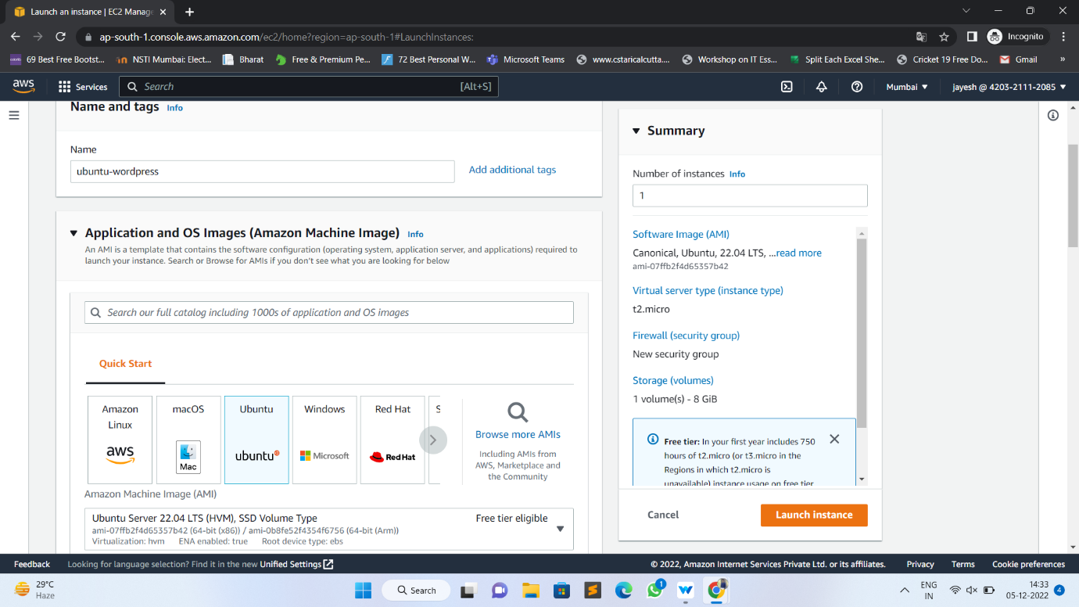

# Select an Existing keypair or create a new key pair

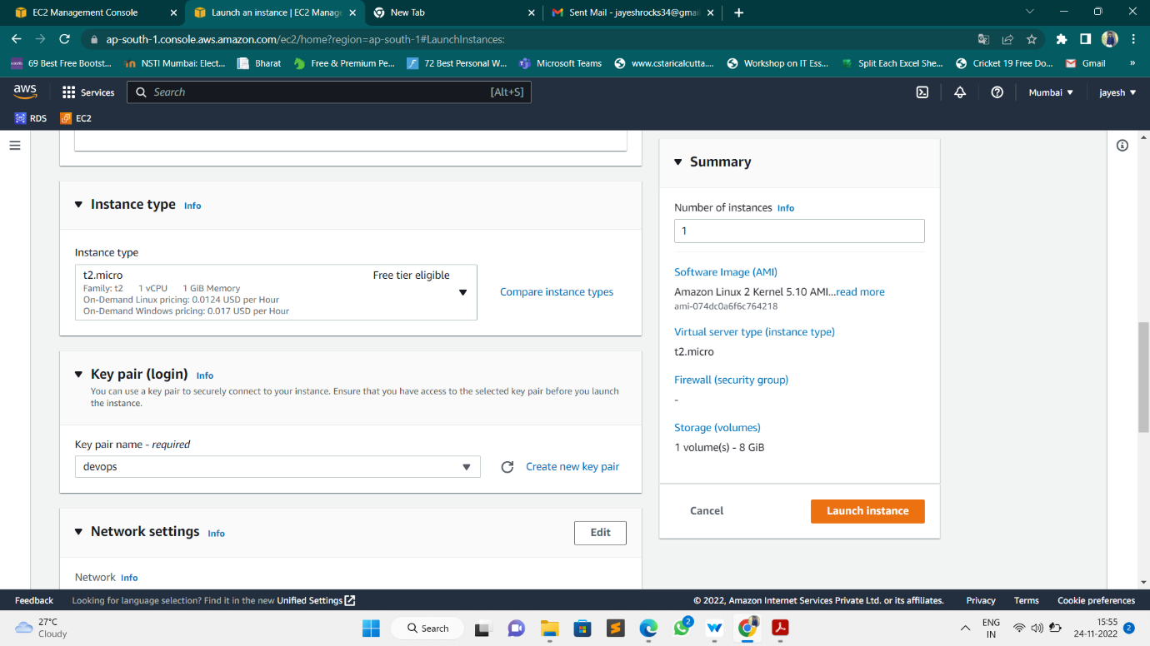

# Configure Security Group

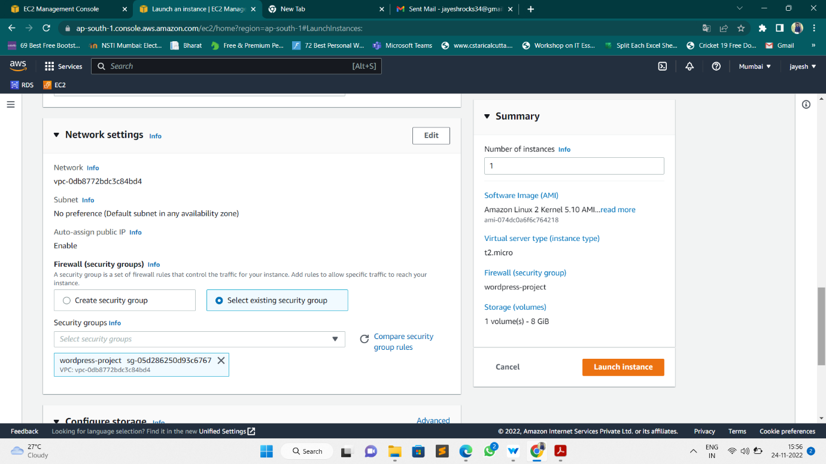

# Finally, Instance launched a WordPress Instance.

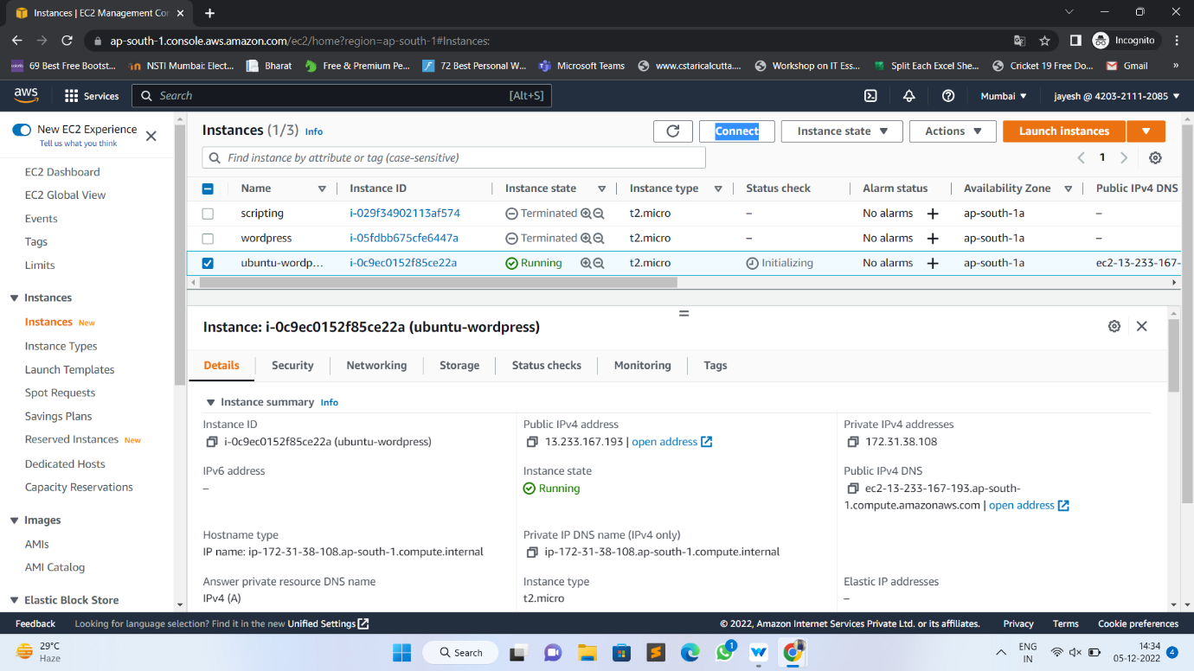

# By using SSH command we are accessing our instance in Command Line Interface Terminal

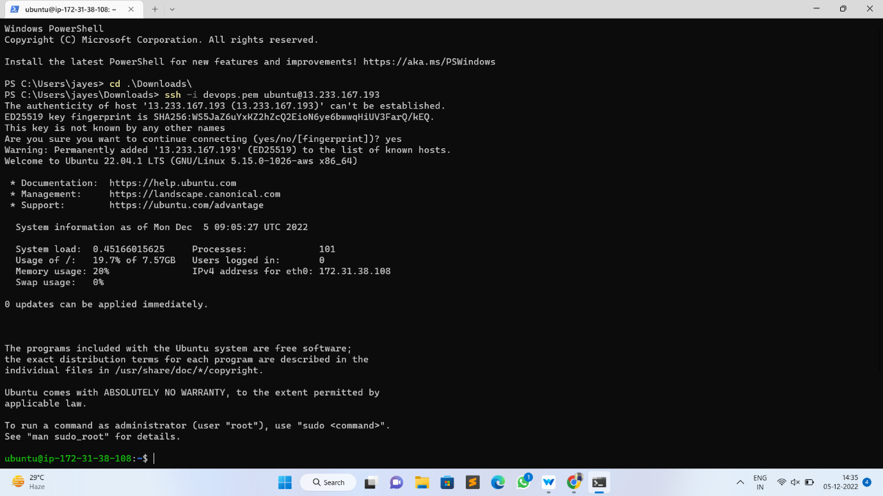

# Step – 2: Installing GIT, Docker and related repos using script

# Created a script file named as wordpress.sh

# 

# Here are the commands used in script to install git, docker, docker-compose

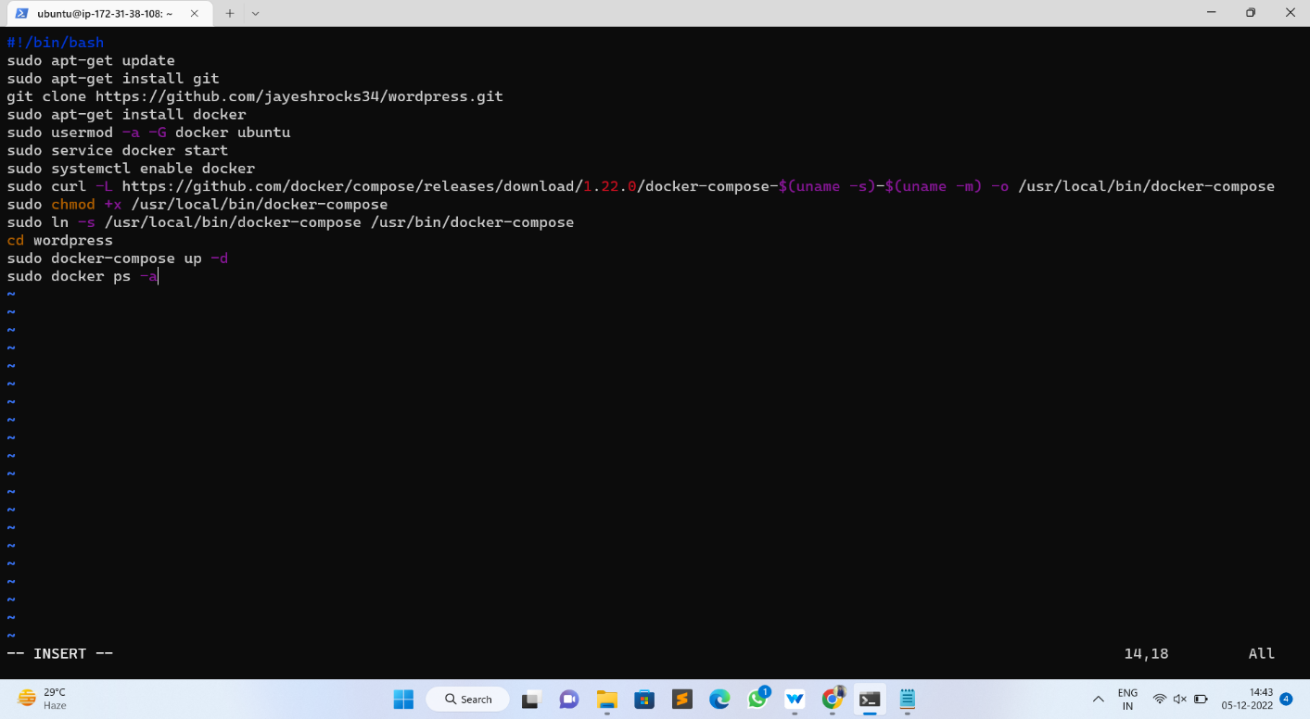

# Then we give executable permission to the created file using below command

# Sudo chmod +x wordpress.sh

# Then run the created script file using following command

# ./wordpress.sh

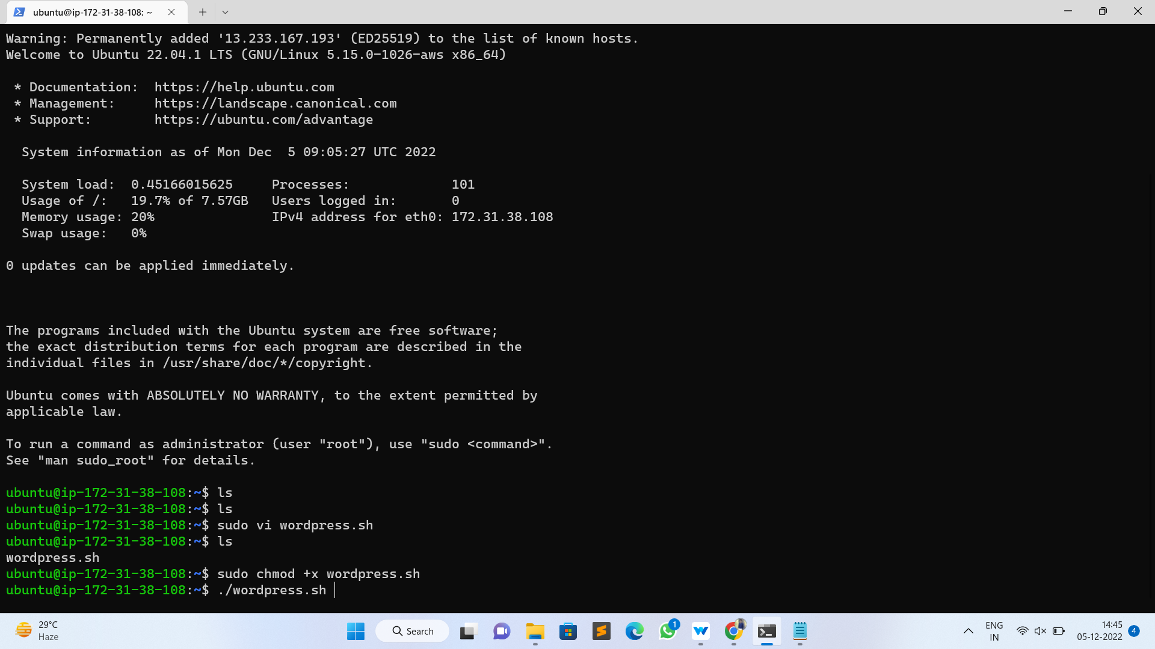

# Then on browser paste the public Ip address of our instance and we got our WordPress started

